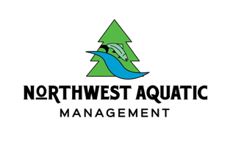
9727 Hwy 12 SW #369
Rochester, WA 98579

2023 Aquatic Herbicide Treatment
Tempo Lake HOA Business / Residential Notice

Business and Residential Notice

This notice is delivered to residents and businesses that are within the treatment zone or within ¼ mile of a treatment zone.

Distribution Date: 21 July 2023

Tempo Lake shoreline, will be treated TWICE with aquatic herbicide between the dates of 15 June 2023 and 31 October 2023. All days/weeks WILL NOT incur treatment. Shoreline Notifications will be posted days of treatment.

Product(s) planned for use: Fluridone, Tribune, Aquathol K, Imazapyr, 24D, Glyphosate, Flumigard

Active ingredient(s): Fluridone, Diquat Dibromide, Dipotassium Salt of Endothall, Isopropylamine salt of Imazapyr, Dimethylanine Salt of 2, 4-Dichlorophenoxyacetic Acid, Glyphosate, Flumioxazin

Plants/Algae targeted: Pondweeds, noxious lily pads and other nuisance submerged vegetation.

Location of treatment(s): The heaviest areas of growing vegetation around the shoreline perimeter of the lake.
The applicator will post signs in the treated and potentially affected areas no more than 48 hours prior to treatment. The signs will describe any water use restrictions or advisories.

If you are withdrawing water for potable or domestic water use, livestock watering, or irrigation, and have no alternate water source, please contact Northwest Aquatic MANAGEMENT at info@nwaqua.com to arrange an alternate water supply.

If you want additional notification prior to treatment, or have further questions, please contact me using the information above.

This herbicide treatment is regulated under a permit issued by the Washington State Department of Ecology. Permit No. WAG994652

